Renju lesson on July 26, 2001

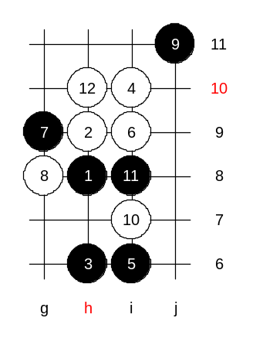
Hello all! Welcome to Online Renju Class. Today is our last lesson. After today’s lesson, we will have a break regarding our lessons. However, the server renjuclass.com will still work. You will be able to use message boards, download materials, and most important – play renju games in our server. We will continue lessons in September.

Today we will discuss a renju game. I have selected a game Zhang vs Nikonov for discussion.
In the game, Zhang Jinyu was black. Nikonov played the 12th move that is very popular in Russia now. We have not studied it in renju class yet. 12-h10.
The database statistics does not give us any good hints about this variant. Both black and white seem to win here equally.

Now, some words about the analyses:
There are three 13th moves that are worth for serious look – g6, j8, j9.
Zhang chose j8, that is the most popular move now.
What do you think is the standard white 14th move here? Yes, so did Nikonov play – j9.
Now, Zhang made the most surprising move. He made a move that others before him never played, and it had only been studied in analyses. We must also be aware, that the statistics is not very clear, because there are only a few games played by this 12th move, therefore anyone’s move is almost new move.
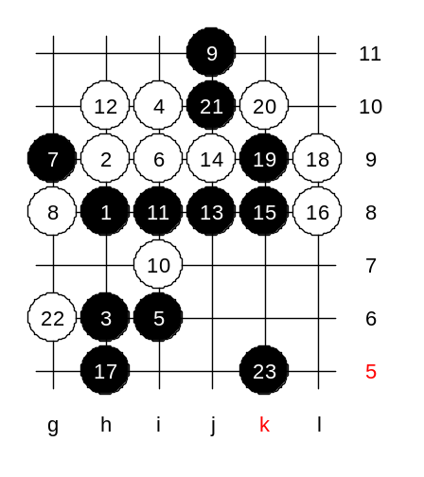
Move 17-L9 is now popular in Taiwan. But Zhang played in brave style – h5. This is a puzzle. It is a surprise for me that many high level players didn’t play that move before. I cannot make any sure conclusions of it yet.
Nikonov seemed to be confused of this move, or was it that his home analysis didn’t prove any better ideas, so he just played passively.
Note that in case of email game, both players have lots of time to do serious analysis about their games, and the quality of the game is higher. So we can pretty much trust Nikonov’s conclusion here.
Nikonov continued passively – 22-g6. Black seems to be very strong here. But yet it is not easy to attack here. Too straight style may even give white win here.
But Zhang did the right thing – he didn’t attack directly, but just developed more lines. Nikonov’s hope must have been that black makes a mistake here, but black didn’t make a mistake.

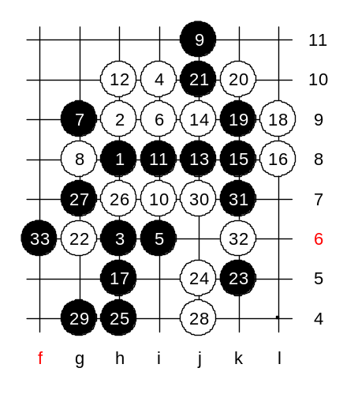
Can you guess Nikonov’s next move? He played j5. After that black won directly. Mostl likely, there was no other defense either. Black’s win idea is simple. Black wanted to get the points g4 and h4 so much, but before it was impossible. But now, thanks to k5 stone, black can have defense piece to k7. Therefore the points g4 and h4 are OK for black now. However, still the sequence is important.
Moves 25 and 27 are very good.
Nikonov played 28-j4 – the strongest defense. But Zhang was confident, and won fast. Nikonov resigned after 33rd move.
This game tells us a lot about black ideas for this 12th move.
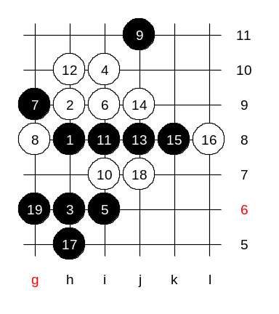
Any questions? We can check now. OK, you all are curious about L9. OK, lets play 18-j7 and see what happens. Does black have VCT?
I can smell a VCT here. How about you? I go 19-g6. How to block?

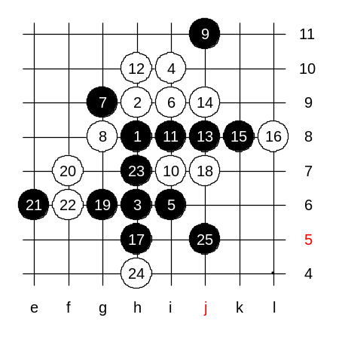

It seems white’s four is a mistake, black wins here (according to Zhang’s comment in renjuclass).

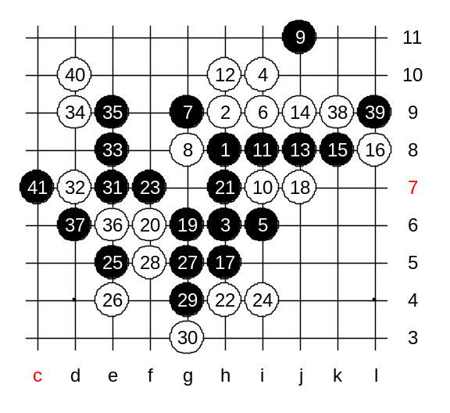

Chenwei’s attack:

